Identifying Biomolecules.

Part 1. Testing the controls

Station 1: Simple Sugars Control Test:
Reducing Sugars
Some sugars such as glucose are called reducing sugars because they are capable of transferring electrons to other compounds, a process called reduction. When reducing sugars are mixed with Benedicts’ reagent and heated, a reduction reaction causes the Benedicts reagent to change color. The color varies from green to dark red (brick) or rusty-brown, depending on the amount of and type of sugar.
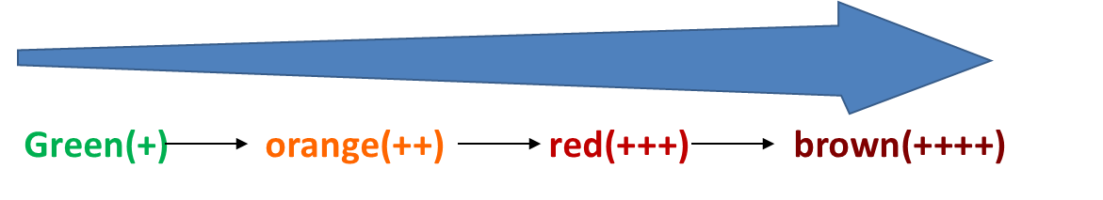
Increasing amounts of reducing sugar

Image Credit: Veronica Amaku. Houston Community College, Houston, TX
- Label six test tubes as listed below:
  - Test tube #1: distilled water + Benedicts
  - Test tube #2: glucose solution + Benedicts
  - Test tube #3: onion solution + Benedicts
  - Test tube #4: Potato solution + Benedicts
  - Test tube #5: starch solution + Benedicts
  - Test tube #6: Sucrose solution + Benedicts
- Place 10 drops of each solution in the appropriate test tube.
- Add 10 drops of Benedict’s solution to each test tube.
- Place the test tubes into a boiling water bath for three minutes.
- Any color change from blue (the color of Benedict’s solution) indicates a positive test for simple sugars.
- Record your data

Station 1 – Simple reducing sugars test
Solution | Color before heating | Color after heating for 3 mins | Is this a positive (+) or negative (-) reaction?
Distilled water
Glucose solution
Onion solution
Potato solution
Starch solution
Sucrose solution

Question: Is sucrose a reducing sugar? Why /why not?

No, sucrose is not a reducing sugar the present two monosaccharide are held together by a glyosidic much linkage between C1 of α-glucose and the C2 of β-fructose

Station 2: Complex Sugars Control Test
Iodine solution (Lugol’s) reacts with starch to produce a dark purple or black color. KI Reagent: Iodine is not very soluble in water, therefore the iodine reagent is made by dissolving iodine in water in the presence of potassium iodide. This makes a linear triiodide ion complex which is soluble. The triiodide ion slips into the coil of the starch causing an intense blue-black color. If you were to set up an Iodine test, you would perform the following:
- Label two test tubes CS+ and CS- (for complex sugar positive and complex sugar negative).
- Place 10 drops of water in the test tube labeled CS-. Place 10 drops of starch solution in the test tube labeled CS+.
- Add four drops of Lugol’s solution to each test tube.
- A color change from yellow/brown (the color of Iodine soln.) to black indicates a positive test for complex sugars.
- Record your data.
Station 2: Complex Sugars Test
CS+ | CS-
Black | -Not Black-

Iodine stains cornstarch because amylose within the starch plays great part in the formation of blue deep color, this indicates the presence of iodine.

Station 3: Lipids Control Test
Brown Paper Test
Certain kinds of paper such as a piece of brown paper bag can readily absorb lipids and can be used to test for the presence of lipids.
- On a brown paper towel, label one side L+ and one side L- (for lipid positive and lipid negative).
- Add 1 drop of water to the L- side and 1 drop of vegetable oil to the L+ side. Allow the drops to dry.
- A stain indicates a positive test for lipids.
- Record your data in your science notebook.
Sample result:
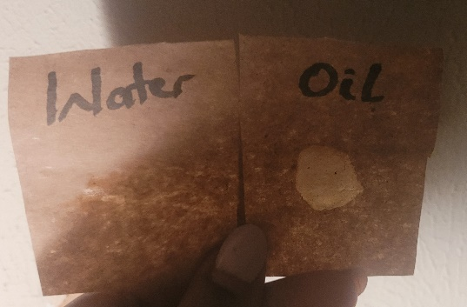

Image Credit: Veronica Amaku. Houston Community College, Houston TX.

Station 4: Proteins Control Test:
Biuret Test
The copper atoms of Biuret solution (CuSO4 and NaOH) will react with several peptide bonds on polypeptides, producing a color change from blue to a deep violet or blue color. Sometimes a light pink color may result in the presence of small peptide chains.
Color | Indication
Blue | No protein or peptides
Pink to Indigo | Protein
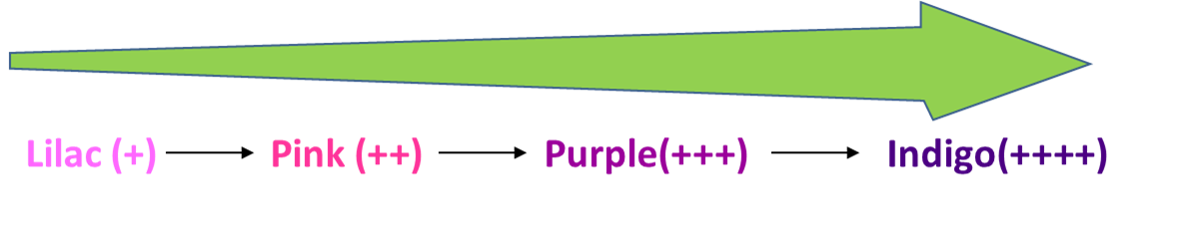

The principle behind biuret’s reagent giving a purple color for proteins is that, on heating the biuret having the copper sulfate within the alkaline solution, there if the formation of the purple color.
Image Credit: Veronica Amaku. Houston Community College, Houston, TX
- Label two test tubes P+ and P- (for protein positive and protein negative).
- Place 10 drops of water in the test tube labeled P -.
- Place 10 drops of albumin solution in the test tube labeled P+.
- Add 10 drops of Biuret’s solution to each test tube.
- Place the test tubes into a boiling water bath for two minutes.
- A color change from blue (the color of Biuret’s solution) to pink or purple to indigo indicates a positive test for proteins.
- Record your data.
When you are finished with your tests, empty test tubes into an approved container and clean thoroughly. Throw away paper towels. Clean your lab area, and wash your hands.

Part 2 - Identifying Biomolecules in Food

The Case: How dare you?
You are the chief nutritionist at the newly established school canteen. You are working with a new set of interns from the culinary department to prepare baby meals. You tasked one of the interns with the responsibility of blending the meals into purees. The intern did, but failed to label the meal samples. You are clearly upset with the intern; however, as the expert, it is your responsibility to determine what type of food(s) is/are in the ground containers and place the appropriate label on each.
The meal samples:
Apple juice
Chicken broth
Egg white
Ground tuna
Liquefied Potato
Rice solution
Vegetable oil
They are temporarily labelled as unknowns 1 to 7. You will design an experiment to determine the appropriate labels for the food items.
Effectively collaborate by splitting up the work and then checking with each other.
When you complete your analysis, you will construct a table and write a report to determine how your team arrived at your conclusion.

Sample Data Entry format: Enter your data for each food type tested in the correct box by placing an ‘x’ for each biomolecule present.
Food | Simple Sugars | Complex Sugars | Lipids | Proteins
Apple juice | x
Chicken broth |  |  | x | x
Egg white |  |  | x | x
Liquefied Potato | x
Vegetable oil |  |  | x
Rice solution
Ground Tuna

http://faculty.uncfsu.edu/jraynor/BIOL%20200%20Online%20Lab/Biological%20Molecules%20Lab.htm
https://www.sisd.net/cms/lib/TX01001452/Centricity/Domain/4741/Identifying%20Biomolecules%20in%20Food%20REDO%20STUDENT%20HANDOUT.pdf
General Biology BioSci 100 4th Edition by Dilek Sanver-Wang – College of the Canyons
Case CC BY Veronica Amaku, Houston Community College.

